ARA - Access Risk Analysis
VIRSA 4.0 ----- > Compliance Calibrator (CC)
GRC AC 5.1, 5.2, 5.3 ------ > Risk Analysis & Remediation (RAR)
GRC AC 10, 10.1,12 ----- > Access Risk Analysis (ARA)

What is difference between ARA (AC) and RM (GRC)?
ARA - Component of AC which deals with Risks related to SAP Access/Authorizations
RM - Component of GRC, which deals with over all risks in Org
- Strategic Risk.
- Compliance Risk.
- Operational Risk Ex,, COVID
- Financial Risk.
- Reputational Risk.

Risk: Futuristic - Something which impacts your business – Financial/ Reputational/Operational/Natural
- Probability – Chances of its occurrence – Depends on Experience or knowledge
Ex, Betting – 50% probability of Losing
- Risk is not universal – Risk depends on local factors- It varies from company to company or location.

ARA deals with only Access/Authorization related risks.

Ex, Reliance Power
Maharashtra – 5^{th of} every month
MP – 10thof every month
Gujarat – 15thof every month – Supply power to 10K industries
Payment Receiving (T1) + Payment Adjustments (T2)
SOD risk – T1 + T2 because of not segregating the duties which are conflicting in nature, this risk occurs.

Terminology:
Action ----- > T-code
Permission ----- > Auth Values (Auth Objects, Auth Fields and Values)

- Access Risk – Identification – Risk Analysis & Simulation
- Access Risk – Remove or Avoid – Risk Remediation
- Access Risk – Reduce its impact/Control – Risk Mitigation

Risk Identification:
To identify a Risk – Experience/Knowledge – Self or Others
SAP has studied famous companies in the world, domain wise – Banking, Automobile, Retail etc – Gathered the risks faced by this companies and that has been documented – Global Rule Set
Global Rule Set – It is database of Access Risks, faced by reputed companies in the last 100 years and risks have been Organized process wise (Finance, HR, Sales…)
Note: This risk data can be loaded in to your system through BC sets related to GRAC*RULESET* activation. (TCODE: SCPR20)
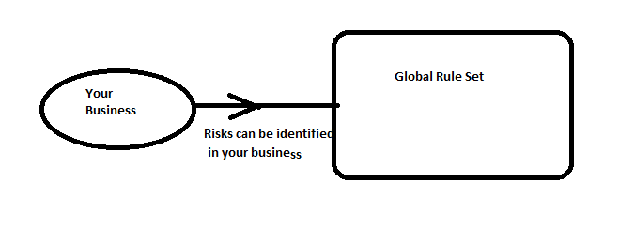
Risk Types:
- SOD Risk – Combination of conflicting functions –
Action Level = SU01+SCC4, SCC4+STMS
, ME21N+MB01, FB01+FBVO
Permission Level = Auth Values of SU01 + Auth Values of SCC4
- Critical Action Risk – SCC5, SE38, SPRO
- Critical Permission Risk – SCC5 : S_TABU_DIS with Activity 01 or 02,SE38: S_DEVELOP With Activity:01 or 02
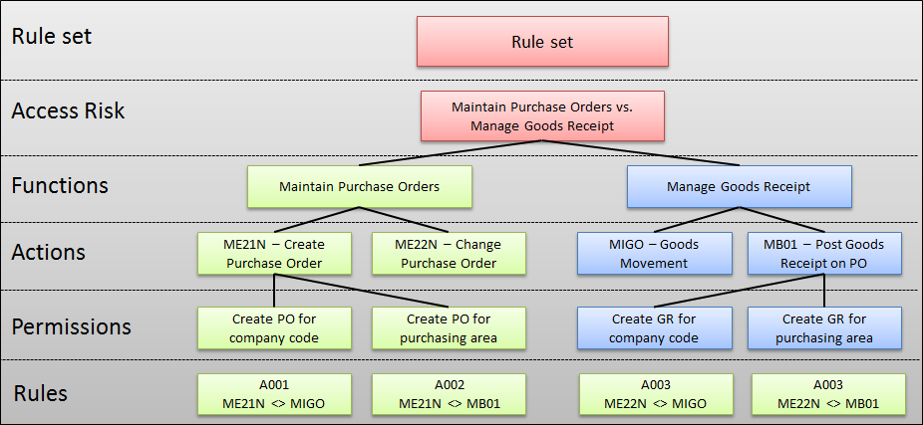
Why do we go for Custom Rule set?
- To define new Risks which are not part of GLOBAL
Ex,, Custom T-codes
- All Risks in GLOBAL may not be applicable to our Business.

Steps to create custom rule set:
- Rule set Creation:
NWBC ----- > SET UP ------ > Access Rule Maintenance ----- > Rule Set
Create a Custom Rule set as per your Client Requirement - Name
- Business Processes: (Departments)
SPRO ----- > GRC ------ > Access Control -------- > Maintain Business process and Sub processes

- Function Creation:
NWBC ----- > SET UP ------ > Access Rule Maintenance ----- >Functions
ECC - ECCCLNT100
BW - BWCLNT100
HR - HRCLNT100
ARA: Risk Analysis Function Creation
BMW_GROUP
ECCCLNT100
BWCLNT100
HRCLNT100
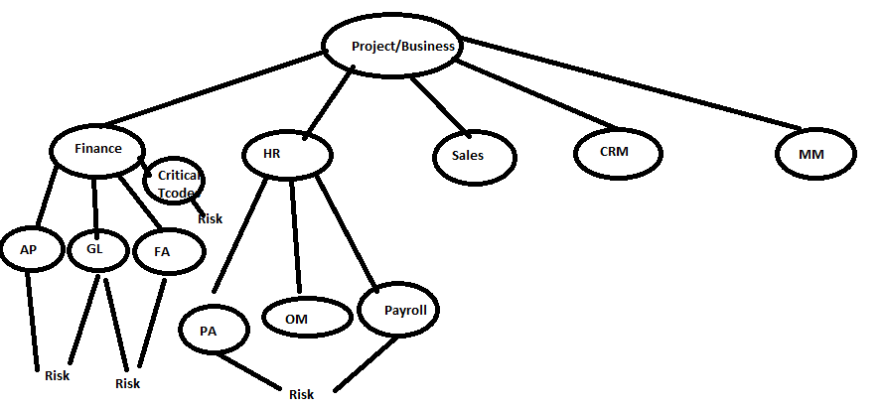
SOD Risk at Action Level:
To create a SOD risk, we need Business process, 2 functions and T-codes/Auth data in Functions
Ex, Business Process ----- >BASIS (GE_BASIS)
Path: SPRO --- > GRC ---- > AC ----- > Maintain BPs and Sub Processes
Functions --------- >GE_SEC:SU01, PFCG, GE_CLAD: SCC4, SCC5, SCCL, SCC9
SOD Risk: GE_SOD1 = GE _CLAD + GE _SEC
EX, SU01 + SCC4 combination is a Risk
SU01 = User Maintain
SCC4 = Client Creation
Once the Risk ID is created, we need to generate the rules
Rules = Risk causing combinations Ex,, SU01+SCC4

SOD Risk example:
Finance Risk: F017---- > Maintain bank account and divert incoming payments

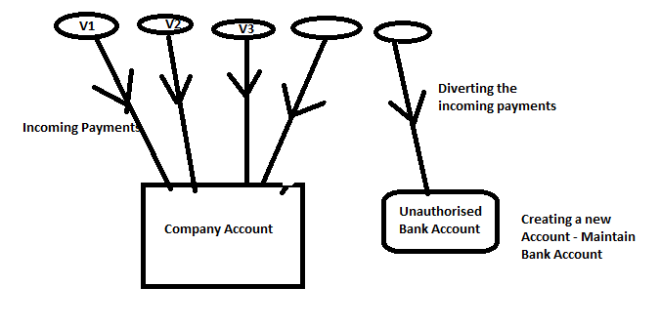

SOD Risk at Permission Level:
- SU01+SCC4 = Display Access of SU01 = S_USER_GRP
With Activity: 03 and CLASS: *

SU01 ---- > S_USER_GRP with Activity: 01/02/05/06/22
SCC4 ----- > S_TABU_DIS with Auth Group: SS, Activity: 01/02

User 1
SU01 ------ > S_USER_GRP
Actvt: 01

SCC5 ------ > S_TABU_CLI
Clientmaint:

- STMS Full+ SCC4 Full --- > combination is risk causing
SU01:
- S_TCODE with TCD: STMS
SCC4:
- S_TCODE with TCD: SCC4
- S_TABU_DIS with Activity: 01or 02 & Auth Group: SS

Example:
SU01+SCC4
Can create a user + Client Settings = Risk

SU01 Display + SCC4 Display = Not Risk
SU01 Display + SCC4 Maintain = Not Risk
SU01 Maintain + SCC4 Display = Not risk
SU01 Maintain + SCC4 Maintain = Risk

SU01
S_USER_GRP (user Creation)
Activity: 01 or 02 or 06 0r 22 or 05
S_USER_AGR
Activity: 01 0r 02 0r 06
S_USER_AGR (Role Assignment)
S_USER_PRO (Profile Assignment)
SCC4
S_TABU_DIS
Activity: 01 or 02
Auth Group: SS
User1 = SU01 Display + PFCG Maintain
SOD Action level = SU01+PFCG = Risk
SOD Permission Level = SU01 Display + PFCG Maintain = Not risk

USER1
SU01
S_USER_GRP
Activity: 01

User2:
S_USER_GRP
Activity: 02
Critical Action Risk:
To create a Critical Action Risk, we need one function which contains all critical t-codes in that Business process.
PG_CAF: SPAM, SPRO, SU25, SCC5, SU24
PG_ RISK2 ---- > PG_CAF
Critical Permission Risk:
To create Critical Permission Risk, we need one function which contains all critical Auth Values – Auth Objects, Auth Fields and Values
(No T-codes)
PG_CPF:
SCC5: S_TABU_CLI with CLIENTMAINT: X
SE38: S_DEVELOP with ACTVT: 01 or 02
CAT_RK3 ------ > CAT_CPF
Action = T-code
Permission = Auth Values


Risk Levels: (based on impact done to business)
- Low
- Medium
- High
- Critical
Risk Analysis path:
NWBC ------- > Access Management ---------- > Access Risk Analysis

Risk Analysis Report Formats:
- Detail – gives you max info
- Summary
- Management Summary
- Executive Summary

Risk Analysis Levels:
- User Level
- Role Level
- HR Objects Level – Position/Org Unit/Job
- Profile Level

Which is preferable: User Level or Role Level?
Role Level Risk Analysis ----> to detect Critical Action/Permission Risk
Role1: SU01 ----- > No Risk
Role2: SCC4 ----> No Risk
Role3: SPRO ---- > Critical Action RISK/Permission

User Level Risk Analysis ----- > to detect SOD risks
User1 --- > SU01+SCC4 ---- > SOD Risk
Role1
Role2

Role level
Critical Action Risk
Critical Permission Risk

User Level
SOD Risk
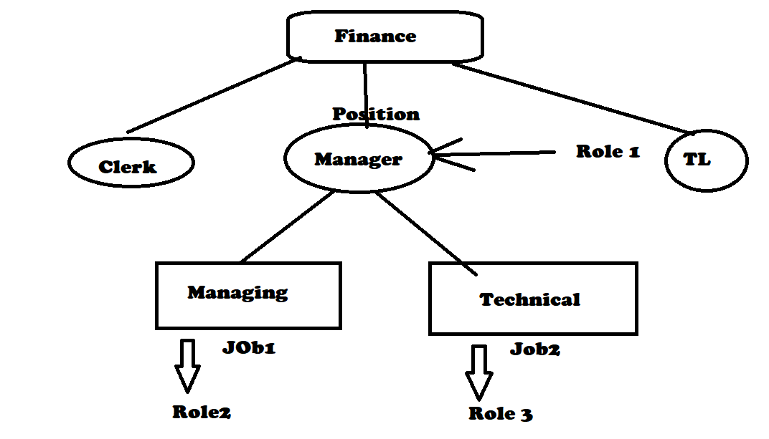

Risk Simulation:
- User Level = Whenever User asks for extra access
- Role Level = Whenever role has to be modified (adding/removing t-codes or authorization from the roles)

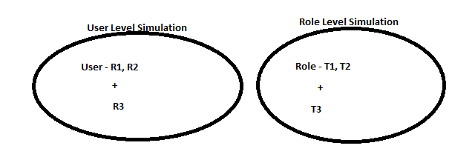
Risks from Simulation Only? ----- > To check the risks coming due to adding of a t-code/role/profile to user (It does not show already existing risks)
Exclude Values? -------- >To check left over risks, when T-code/role/profile is removed from User. (Ensure that T-code/Role should be assigned to User)
Simulation can be done in 2 levels
- User level
- Role level
Role Level Simulation:
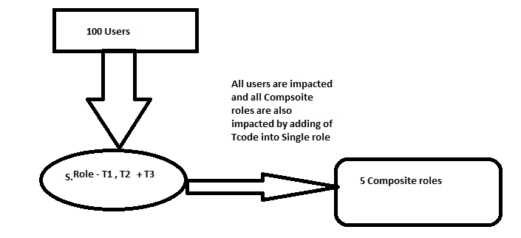
Defining Risk Owner:
Risk Owner:
Risk Owners are assigned to risks and are commonly responsible for approving changes to risk definitions and violations of the risk. Risk Owners may also receive conflicting and critical action alerts.
Steps to define Risk Owner:
- Ensure the user id is present in the GRC system with the necessary Authorizations.
- Declare that user id as Risk Owner in the below path
NWBC ---- > SET UP ----- > Access Owners ---- > Access Control Owners
- Open the Risk ID and define the above id as Risk owner for that particular Risk ID

Risk Analysis Report is sent to Risk Owner in 2 ways
- Manual – Download the report and send mail
- Automated – ARM Concept – Access request Work flow

1st Priority: To Remediate Risk (Removal of a Risk)
2nd Priority: To Mitigate Risk (Risk Reduction/ Control Risk)

Risk Remediation:
It means removing risk by removing access
How to remove access to user?
1) Role modification - Remove the risk causing T-code/Auth Values from the role that is assigned to user - Multiple Users
2) Role removal from the user - Unassign the role - SINGLE USER
USER1
ROLE 1 ---- > SCC5, SCC4, SCCL, SCC9
Solutions:
1. Removing the role to user:
User is left with no access

2. Remove Tcode from the Role1
Role1 is assigned to 10 other users

3. Search/Create a role without SCC5, copy of Role1
Assign this to USER1

NBA_USER1 has risk

When you run risk analysis to all users in System
GE_RSK1 is available to 100 users
GE_RSK1 is caused due to Client Admin and SEC Admin
100 users = 20 BASIS Team + 80 Non BASIS Team
There is only one role assigned to 100 users.

User Admin role is assigned to 100 Users (BMW_USER1)

SU01+SCC4
SU01+SCCL

Su01 ---- > USER Admin Role
SCC4, SCCL ---- > Client Admin Role

BMW_USER1 belogs to which Team?

1) Security ----- > Remove Client Admin Access
2) BASIS ----- > Remove USER Admin Access
3) Security + BASIS ---->

Removing of User Admin Access:
##########################################################
1) Remove SU01 from User Admin Role ???? Role Modification ?? Approvals ???
2) Create Another ROle ---- > PROCESS ?? APPROVAL ???
3) Remove User Admin Role ----> Other tcodes are also lost, Search for role
which does not contain Su01 and assign that Role to the user.

Risk Mitigation:
Reducing the probability of its occurrence or impact of the risk
How? By monitoring mechanism
Mitigation Controls
- Specific to Business Process (HR, FIN, SD, MM)
- Specific to Organization Hierarchy (Country/Region Specific)
- Ex,, GDPR – General Data Protection Regulation - EUROPE
Mitigation Approver – Responsible for approvals to assign Mitigation Controls for Users and also approving changes to Mitigation Control Definition
Mitigation Monitor – Responsible for monitoring the mitigated users who have risks in the form of Alerts and Notification.
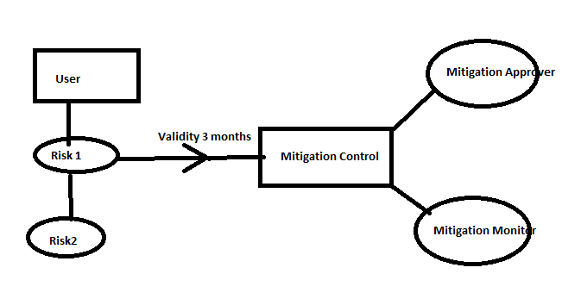

MIT1-----> RISK1, RISK2
MIT2-----> RISK1, RISK3
Replace BHP_MIT_APP1 with BHP_MIT_APP2 as Mitigation Approver
BASIS | Risks | Mitigation Control | Approver | Monitor
 | BS_RISK1 | BS_MIT1 | A1 | M1
 | BS_RISK2 | BS_MIT1
DBA | BS_RISK3
 | BS_RISK4 | BS_MIT1
 | BS_RISK5 | BS_MIT1
 | BS_RISK6 | BS_MIT2 | A2 | M2
 | BS_RISK7
SYSADM | BS_RISK8
 | BS_RISK9
 | BS_RISK10
 | BS_RISK11 | BS_MIT3 | A3 | M3
 | BS_RISK12
OSA | BS_RISK13
 | BS_RISK14
 | BS_RISK15
 | BS_RISK16 | BS_MIT4 | A4 | M4
SYSMON | BS_RISK17
 | BS_RISK18
 | BS_RISK19
 | BS_RISK20

HR | Risks | Mitigation Control | Approver | Monitor
PA | HR_RISK1 | HR_MIT1 | A5 | M5
PA | HR_RISK2
PA | HR_RISK3
PA | HR_RISK4
PA | HR_RISK5
OM | HR_RISK6 | HR_MIT2 | A6 | M6
OM | HR_RISK7
Payroll | HR_RISK8 | HR_MIT3 | A7 | M7
Payroll | HR_RISK9
Payroll | HR_RISK10

Mitigation Control:
Steps
- Ensure user ids exist in GRC system for Mitigation Approver and Monitors
Mitigation Approver Role: SAP_GRAC_CONTROL_APPROVER
Mitigation Monitor Role: SAP_GRAC_CONTROL_MONITOR
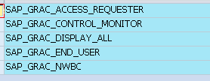
- Define/Declare them in GRC system as Mitigation Approver and Monitor in NWBC ----- > Set up ------ > Access Control Owners
- Create Root Org in SPRO ---- > GRC ----- > Shared Master Data
(Mitigation Controls are specific to Org units) and related Child org if required under NWBC ---- > SET UP ---- > Org
- Define OWNERS for the ORG
- Create Mitigation Control NWBC ---- > SET UP ---- > Mitigation Controls

BASIS team -- 5 BASIS Risks BASIS_MIT1 A1M1
5 BASIS Risks BASIS_MIT2 A2 M2

Finance Team --- 30 Finance Risks FIN_MIT1 A2 M2 AP
FIN_MIT2 A4 M4 FA
FIN_MIT3 A5 M5 GL
Sales Team ---- Sales Risks SALES_MIT1 A3 M3

Note: Every Risk ID should be part of some Mitigation Control, else it cannot be mitigated.

Mitigation Control Validity is controlled by a parameter under the below path
SPRO------ > GRC ------- > Access Control ------ >Maintain Configuration Settings

Parameter ID: 1011 ---- > Default Expiration time for Mitigation Control Assignment
Default Validity: 1 Year (365 days)

Process of mitigating risks:
- User has a risk
- Risk report is sent to Risk owner and decides to Mitigate, it has to be approved by Mitigation Approver
- If they decide to mitigate, we need to link the risk id with appropriate mitigation control
- If Mitigation control is not available for that particular risk, its Security/GRC team duty to create a Mitigation Control.
- Ensure that every risk id is associated with some Mitigation Control otherwise that risk cannot be Mitigated

Batch Risk Analysis:
SPRO ------ > GRC ------ > AC ------ >Access Risk Analysis ---- > Batch Risk Analysis ------ > Execute Batch Risk Analysis
It is performing/running risk analysis for all users & roles in the system and updates the table GRACMGRISKD &dashboards under Reports and Analytics Tab under NWBC
Purpose:
- Risk Analysis Dashboards
- Offline Risk Analysis
- Risk Monitoring Job

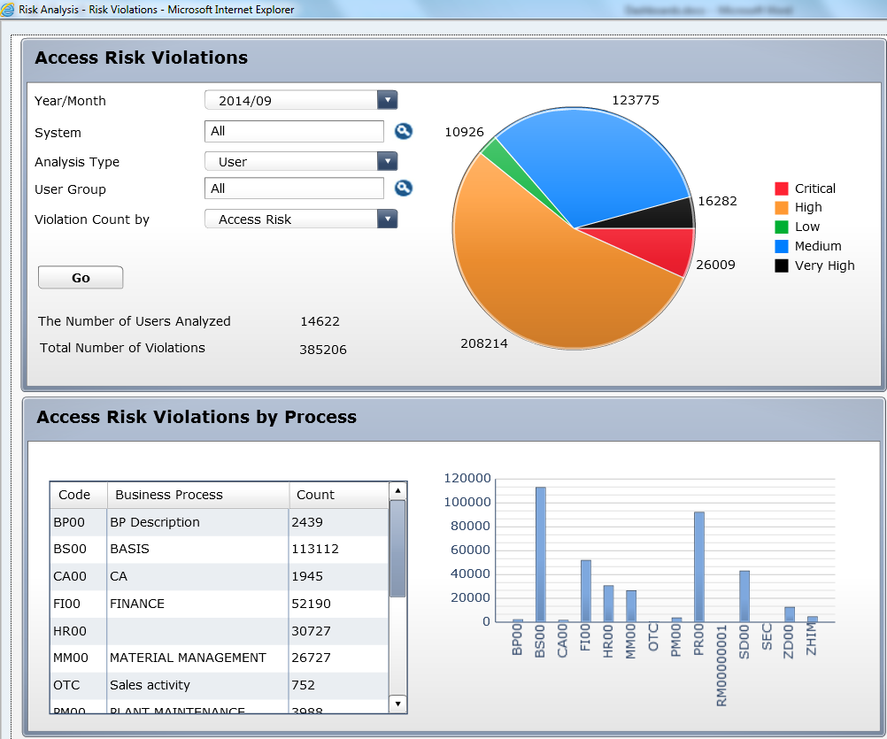
What is difference between Offline Risk Analysis and Online Risk Analysis?
Online Risk Analysis:
- GRC pulls the data from backend ECC and run risk analysis
- Accurate Data and updated data
- System performance – Late response
- If RFC error is there, this fails
Offline Risk Analysis:
- GRC pulls the risk analysis data stored in Local GRC Tables- GRACMGRISKD
(Dashboards) – These tables get updated by BATCH RISK ANALYSIS job.
- It may not be Accurate data and not updated
- System performance – Fast response
- If there is RFC error, still we get the Risk Analysis Report.

Parameter ID: 1027 controls the enabling the Offline Risk Analysis
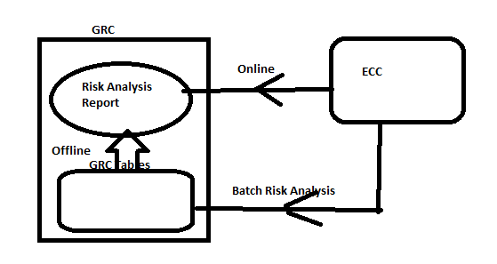

What do you mean by False Positives?
There is no risk ideally, but GRC system shows as a Risk as per the Rule set data defined.
SU53 is Risk ----> RISK
User 1 has SU53 ---> RISK
Example1: 2 conflicting functions have same T-code
AP02 --- > FB01
GL01 ----> FB01
Risk ID: F028 (SOD RISK) ---- > AP02+GL01

User: FB01
Risk Analysis
SOD RISK = F028 = FB01 (AP02) + FB01 (GL01)

Example2: Finance SOD Risk
Action Level Rule: Create Invoice (FB01) & Approve Invoice (FBV0)
Permission Level Rule: FB01 ---- >AO1 with Activity: 01
FBV0 ----- > AO2 with Activity: Approve

User
Role1: FB01 --- > AO1 with Activity 01, Plant: 100 (INDIA)
Role2: FBV0 ---- > AO2 with Activity: Approve, Plant: 200 (JAPAN)

How to avoid FALSE POSITIVES?
- Org rules need to be defined
Org Rule: AO1 with Act: 01 & Plant: 100
AO2 with Act: 01 & Plant: 200
Note: System takes more time when running risk analysis as it has to consider extra rules like Org Rules, Supplementary Rules other than Action rules, permission rules, etc…..
- Create Dummy Mitigation Control and Mitigate the Risk

SOD Rules/ Rule set Upload/Download and Transports:
SPRO ---- > GRC ---- > Access Control ----- > Risk Analysis --- > SOD Rules
Purpose:
- To move data from Dev to QA & PROD
Transports:
What type of Transport Request is needed to move Rule set?
Ans: Customizing TR
After importing into target system (Dev --- > qua --- > Prod), generate the rules for all Risk Ids.

- To modify the rule set data - Mass Changes
Upload Rules:
GRAC_UPLOAD_RULES
Download Rules:
GRAC_DOWNLOAD_RULES

Creating new Risks IDs:
What all files need to be updated?
- Function
- Function Actions
- Function Permissions
- Function Business Process
- Risk
- Risk Description
- Risk Rule Set relationship

Create a new Business Process:
- Business Process
Create a new Function:
- Function
- Function Business Process
- Function Actions
- Function Permissions

When do you do Risk Analysis?
User Administration – User Creation, Modification
Role Administration – Role creation, modification
Maintaining Rule set – BP, Functions and Risk ids
Mitigation Control Maintenance – Creation and Modification
Maintaining Approvers – Risk Owner, Mitigation Approver/Monitor
Parameters Config – Risk Analysis, Mitigation

